**Executive Summary:**

The design of an aircraft fuselage is impacted by the interaction of its functional requirements, its basic strength and stiffness. These multifaceted requirements impose severe restrictions on the basic configuration of the fuselage frame and the structural-material concepts selected for use in its design. New and innovative designs must be explored to accommodate these requirements and to meet the goals of lower weight structure for airplanes. Considerable weight saving potential is forecast with the application of metallic or composite materials to the fuselage. However, before this can become a reality, a state of design readiness must be attained that includes

(1) A thorough understanding of the design process associated with the design of fuselage,

(2) A delineation of the major design process,

(3) The development of the necessary design data base to assess and solve these process calculations.

This report addresses the design process, identifies the major design considerations and discusses their impact on the design of fuselage structure.

This project aims at designing an aircraft fuselage using metallic and composite materials with minimum weight configuration. We have given shear load, a torsional moment, and an axial bending moment, so it was necessary to develop fuselage designs which met all of the design criteria. Under these loading conditions it was necessary to verify that the fuselage designs under consideration would not fail in terms of compression buckling and shear buckling which they would be subjected to. Constraint on skin dimensions given in the problem statement is minimum skin thickness will be 0.032 in.

Design parameters are number of stiffeners, selection of material, cross section of Z stiffener, skin thickness, stiffener thickness and material used. We have assumed that material of stiffener as well as skin is same. All we have done is varied all these design parameters. Trade study is done in following directions to reach at optimum value of fuselage weight.

1. Number of stiffeners kept constant & optimum weight calculated varying other parameters.
2. Af kept constant and optimum weight calculated varying other parameters.
3. Skin thickness kept constant varying remaining parameters.
4. Stiffener thickness kept constant varying other design parameters.
5. All parameters are varied and optimum solution obtained.

Design optimized weight is then determined from above trade studies.

**Given Data:**

Critical section diameter: 40 in

Shear load: 10,000 lb

Torque: 200,000 lb

Bending Moment: -500,000 lb

Spacing between the frames: 20 in

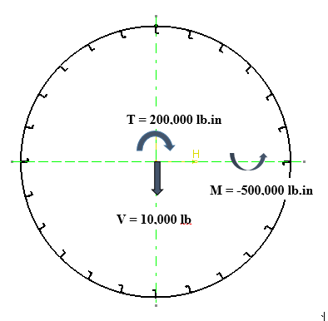

Fig.1. Critical section of fuselage

In order to determine a minimum weight configuration, following parameters were considered:

1. Stiffener spacing ( No. of stiffeners)
2. Skin thickness
3. Area of stiffener
4. Material

Design is based on the assumption that skin carry only shear loads. Aircraft fuselage is designed on the basis of buckling of stiffeners and Shear buckling of skin.

Optimization for above four parameters is done through the MATLAB code. Minimum weight plots were obtained against each of the design parameters. These plots helped in predicting the final dimensional configuration of the structure.

In order to visualize the deformed structure of the fuselage, ABAQUS analysis has been completed with applied set of loads. Results have been analyzed to draw a conclusion that under the same loading condition, composites have higher strength to weight ratio.

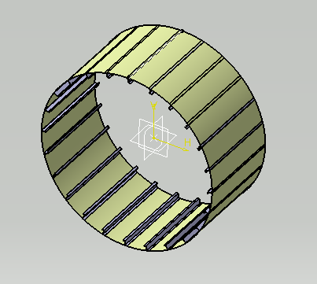

Fig.2. CATIA Model of aircraft fuselage:

As geometry is difficult to generate in ABAQUS, modeling is done in CATIA software. Then model is extracted into ABAQUS database and loads are applied to the geometry. Report also discusses the deformed structure obtained through the ABAQUS.

**Design Trade study process:**

Designing calculations are typically classified in the following categories:

1. Calculation of actual shear stresses in the skin
2. Shear buckling of skin
3. Crippling of metallic stiffener
4. Buckling of metallic stiffener
5. Determination of actual maximum bending stress induced in the stiffener

Detailed study of each of the above cases is as follows:

1. **Calculation of actual shear stresses in the skin:**

The design architecture consists of thin skins and closely spaced stiffeners.

Stiffeners are axial members intended to increase the buckling stress of the skins.

**  **

**;** 

**Resultant shear flow:**





**Shear flow due to bending:**



Shear flow due to torsion:



For calculation of shear flows following tabular format is used. We have shown shear flows calculations in webs with following design parameters:

Number of stiffeners = 24

a = 0.50 in

b = 0.50 in

tskin = 0.04 in

tstiff = 0.042 in

|  |  |  |  |  |  |  |  |  |  |  |
| --- | --- | --- | --- | --- | --- | --- | --- | --- | --- | --- |
| **stiffener no** | **Af** | **y** | **yAf** | **y2Af** | **sum yAf** | **qb** | **qt** | **q** | **thau** | **sigma** |
|  |  |  |  |  |  |  |  |  |  |  |
| 1 | 0.042 | 20 | 0.84 | 16.8 |  |  |  |  |  |  |
|  |  |  |  |  | 0.84 | 20.83335 | 79.61783 | 100.4512 | 2511.28 | -24801.6 |
| 2 | 0.084 | 19.31852 | 1.622756 | 31.34923 |  |  |  |  |  |  |
|  |  |  |  |  | 3.077679 | 76.3314 | 79.61783 | 155.9492 | 3898.731 | -23956.5 |
| 3 | 0.084 | 17.32052 | 1.454923 | 25.20002 |  |  |  |  |  |  |
|  |  |  |  |  | 3.917679 | 97.16475 | 79.61783 | 176.7826 | 4419.565 | -21478.8 |
| 4 | 0.084 | 14.14215 | 1.187941 | 16.80004 |  |  |  |  |  |  |
|  |  |  |  |  | 5.10562 | 126.6276 | 79.61783 | 206.2454 | 5156.136 | -17537.4 |
| 5 | 0.084 | 10 | 0.84 | 8.4 |  |  |  |  |  |  |
|  |  |  |  |  | 5.94562 | 147.461 | 79.61783 | 227.0788 | 5676.97 | -12400.8 |
| 6 | 0.084 | 5.176418 | 0.434819 | 2.250806 |  |  |  |  |  |  |
|  |  |  |  |  | 6.380439 | 158.2452 | 79.61783 | 237.863 | 5946.575 | -6419.18 |
| 7 | 0.084 | 0 | 0 | 0 |  |  |  |  |  |  |
|  |  |  |  |  | 6.380439 | 158.2452 | 79.61783 | 237.863 | 5946.575 | 0 |
| 8 | 0.084 | -5.17633 | -0.43481 | 2.250728 |  |  |  |  |  |  |
|  |  |  |  |  | 5.945627 | 147.4611 | 79.61783 | 227.079 | 5676.974 | 6419.064 |
| 9 | 0.084 | -10 | -0.84 | 8.4 |  |  |  |  |  |  |
|  |  |  |  |  | 5.105627 | 126.6278 | 79.61783 | 206.2456 | 5156.14 | 12400.81 |
| 10 | 0.084 | -14.1421 | -1.18794 | 16.79988 |  |  |  |  |  |  |
|  |  |  |  |  | 3.917692 | 97.16508 | 79.61783 | 176.7829 | 4419.573 | 17537.33 |
| 11 | 0.084 | -17.3205 | -1.45492 | 25.19989 |  |  |  |  |  |  |
|  |  |  |  |  | 2.462773 | 61.08073 | 79.61783 | 140.6986 | 3517.464 | 21478.78 |
| 12 | 0.084 | -19.3185 | -1.62275 | 31.34916 |  |  |  |  |  |  |
|  |  |  |  |  | 0.840019 | 20.83383 | 79.61783 | 100.4517 | 2511.291 | 23956.49 |
| 13 | 0.042 | -20 | -0.84 | 16.8 |  |  |  |  |  |  |
|  |  |  |  |  |  |  |  |  |  |  |
|  |  |  |  | 201.5998 |  |  |  |  |  |  |



Thus we get Af = 0.084 in2

Stiffeners 1 and 13 are shared by two vertical semicircle so their areas are taken 0.042 in2.

Now cross sectional area of fuselage is calculated as



Torsional shear flows calculations in a web:



This torsional shear flow is same in all webs of fuselage.

Now let p be the number of webs in one vertical semicircle. As there are total 24 stiffeners so one half shares 13 stiffeners. So p = 12 i.e. 12 webs are there in one half.



Angle shared at center by two adjacent stiffeners is given by,



And height of stiffeners from origin (origin is at center of fuselage) is obtained by following trigonometric relation



ymax comes out for stiffener 1 and 13 as 20 in and -20 in respectively.

Product of y and Af are taken for the purpose of calculations of shear flows in webs due to bending.



MI of geometry (any vertical half section) is calculated as follows.





It comes out to be 201.5998 in4.

Taking V = 10000 lb we led to the formulation of shear flows in each web by picking per web.



Now we have *qb* and *qt* in each web. Taking clockwise rotation as positive in sign convention total shear flows resulting from these two is calculated for webs and tabulated,



Shear flows in a web is shown in below diagram.

Shear stress in web:



Shear stress depends on skin thickness and is inversely proportional to it. For considered sample case we got maximum shear stress to be 5946.575 psi and this maximum shear stress occurs between webs joining stiffeners 6-7 and stiffeners 7-8. This value will be used to compare with calculated theoretical shear buckling stress.

Skin is effective in carrying only shear loads.

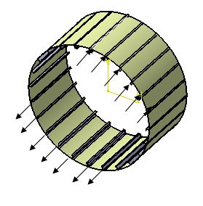

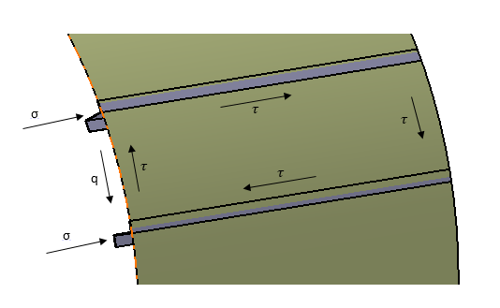

σ : buckling stress induced in the stiffener

q : shear flow in the skin

τ: Shear stresses in the web



Here a = 20 and b = r = 20x0.2618 = 5.23598

Ratio = a / b = 3.8197 and simply supported edges.

From above graph we get K = 5.09015

Taking E from material selection we can get,



Thus theoretical stress is calculated as,

We have to compare for above obtained critical shear stress value with the previously calculated actual stress valve obtained using shear flows.

If the actual shear stress comes out to be less than the design stress value calculated then our design becomes valid and factor of safety is more than 1 for the case.

So for valid design there is essential condition for stress:

Actual shear stress < Theoretical shear Stress …………………..(condition for skin)

τactual < τdesign

Similarly, to check the condition for compression buckling of stiffeners, design stress should be greater than actual stress,

Actual compression buckling stress < Theoretical compression buckling stress

σactual < σdesign

The design is valid if and only if above both conditions are verified. i.e. if the factor of safety comes out to be greater than 1 for both stress checking.

Weight of skin is given by



And similarly weight of stiffener is obtained by



And thus finally the weight of fuselage is nothing but addition of above two weights

